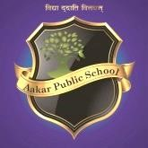
AAKAR PUBLIC SCHOOL

Class 8th
S.NO. | Name | Author | Published Year
1. | Sherlock Holmes : The Complete Series | Conan Doyle | 1887 - 1927
2. | Harry Potter : The Complete Series | J. K. Rowling | 1997 - 2007
3. | Percy Jackson & the Olympians : The Complete Series | Rick Riordan | 2005 - 2014
4. | A Study in Scarlet | Arthur Conan Doyle | 1887
5. | Chronicles of Narnia | CS Lewis | 1950
6. | Luka And the Fire of Life | Salman Rushd | 2010

